

LAB REPORT

CSE312: Database Management System Lab

|  |
| --- |
| 03 [Report Number] |

**Topic:** Implementing SELECT Command and SQL Functions

Submitted To

Shadman Rabby (SHR)

Lecturer

Department of CSE, Daffodil International University

Submitted By

Student ID: 221-15-5261

Section: 61_J2

Student Name: Munna Biswas

Date of Assignment Submission: 26 November, 2024

|  |  |  |
| --- | --- | --- |
| Experiment No: 03 | | Mapping: CO1 and CO2 |
| Experiment Name | Implementing SELECT Command and SQL Functions | |

**Experiment Details**

**Objective**

* Understand the usage of the SELECT clause with various options like DISTINCT and calculated fields.
* Explore aggregate functions like MIN(), MAX(), AVG(), COUNT(), and their combination with ORDER BY.
* Implement GROUP BY with HAVING clause and differentiate it from WHERE clause.

**Equipment**

* Database Management System: MySQL Workbench (or another SQL tool).
* Sample database: EmployeeManagement.

**SQL Code**:

1. **Create the Database**:

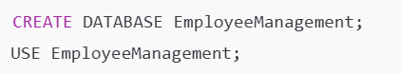 

1. **Create the Employees Table**:

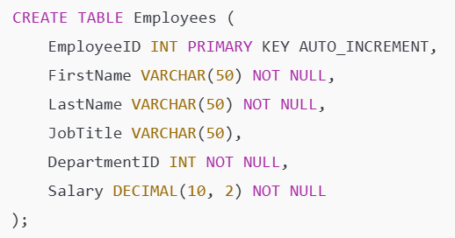 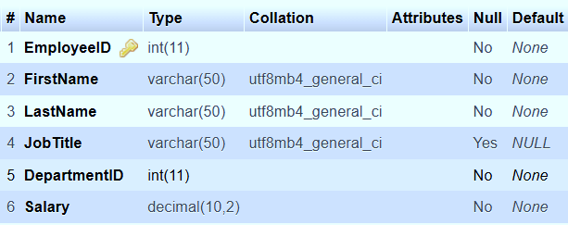

1. **Insert Sample Data into Employees Table**:

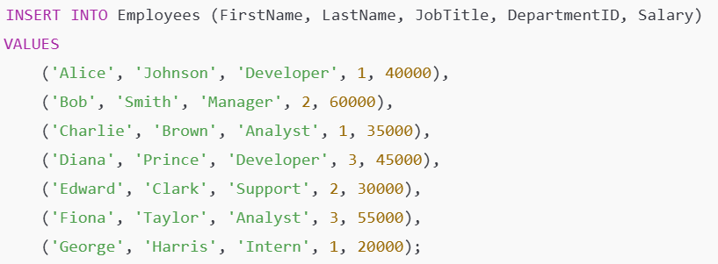 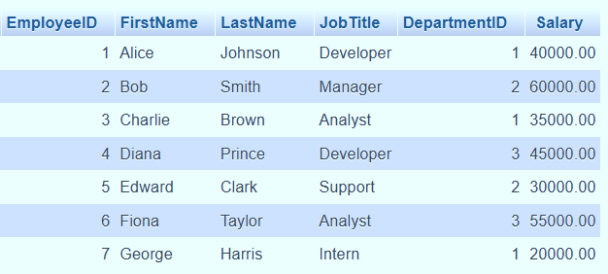

1. **Lab-3: SELECT Command / Aggregate Function**
   * **SELECT Clause with DISTINCT**:  
     Retrieve distinct job titles from the Employees table.



* + **Calculated Fields and Alias**:  
    Calculate annual salary and rename it as AnnualSalary.



* + **Comparison, Range, and SET Membership**:  
    Retrieve employees with a salary between 20000 and 50000 or those in specific departments.

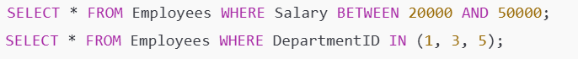

* + **Pattern Matching (LIKE)**:  
    Find employees whose names start with 'A'.



1. **Lab-4: Aggregate Functions + ORDER BY**
   * **Using Aggregate Functions**:  
     Calculate the minimum, maximum, and average salary.



* + **COUNT with Conditions**:  
    Count the number of employees in a specific department.



* + **ORDER BY Clause**:  
    Retrieve employee details ordered by salary in descending order.



1. **Lab-5: GROUP BY + HAVING Clause**
   * **GROUP BY Implementation**:  
     Group employees by department and calculate the total salary.



* + **HAVING vs WHERE**:  
    Filter grouped data with HAVING and differentiate it from WHERE.

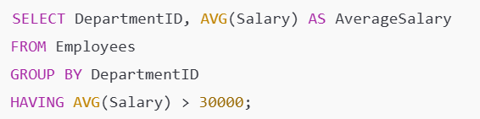

**Obtained Output:**

|  |  |
| --- | --- |
|  | Desired Output? |
|  | YES |
|  |

**Alternative Steps/Solution (If any):**

None for the current requirements.

**Observation/ Comments:**

* DISTINCT and calculated fields provide powerful data representation options in SELECT.
* Aggregate functions are vital for summarizing data.
* HAVING is used for grouped data, whereas WHERE applies filters before grouping.

**Appendix**

Course Outcomes, Complex Engineering Problems (EP), and Complex Engineering Activities (EA) Addressing.

**COs Mapped:**

* CO1: Demonstrates a comprehensive understanding of constraints and cascading rules.
* CO2: Successfully implements and optimizes relational database operations.

Engineering Problem: EP1, EP2